### Key Attribute

* An attribute X of entity E is a key attribute, when X has a unique value per each instance of entity E.

Examples:

John Smith is an instance of entity EMPLOYEE.

SSN is a key attribute for entity EMPLOYEE, because SSN of each employee is unique.

* 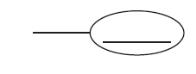It is shown by
* What can you conclude about “Name” and “Number” in the following ER diagram?

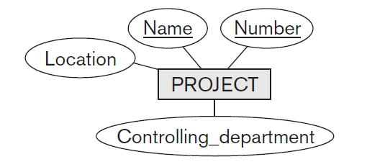

* An entity may have more than one key.
* 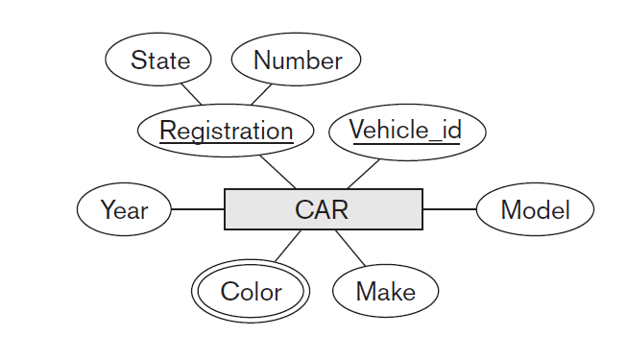A key attribute might be composite.

### Value Sets (Domains) of Attributes

* The set of all possible values for an attribute.
  + Example, what is domain of attribute phone number?
* Why do we need to know value set of an attribute?

## Practice Time!

* Now we know enough to create entities from a project description. The textbook uses the COMPANY example and its description copied here:

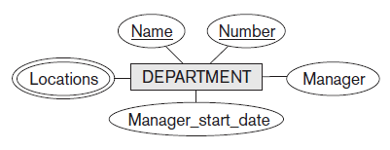“The company is organized into departments. Each department has a unique name, a unique number, and a particular employee who manages the department. We keep track of the start date when that employee began managing the department. A department may have several locations.

”

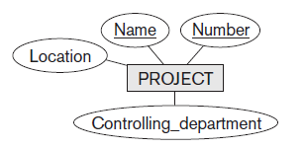“A department controls a number of projects, each of which has a unique name, a unique number, and a single location.”

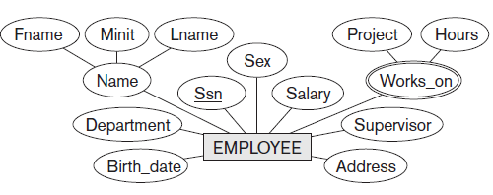“The database will store each employee’s name, Social Security number,2 address, salary, sex (gender), and birth date. An employee is assigned to one department, but may work on several projects, which are not necessarily controlled by the same department. It is required to keep track of the current number of hours per week that an employee works on each project, as well as the direct supervisor of each employee (who is another employee).”

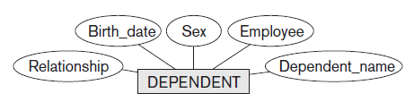“The database will keep track of the dependents of each employee for insurance purposes, including each dependent’s first name, sex, birth date, and relationship to the employee.

”

The ER developed so far for the COMPANY is in initial step!

* Probably you have noticed some attributes are not either simple, composite or multivalued! They are another entity by themselves. Such as “Manager” in DEPARTEMENT entity or “Controlling_department” in PROJECT, etc.
  + They will be removed and re-drawn as RELATIONSHIPs!

An ER composted of entities, attributes and relationships.

## RELATIONSHIP

* A relationship relates two or more entities to carry a specific meaning.
* For example “a particular employee who manages the department.”

First rewrite it as: an EMPLOYEE manages a DEPARTMENT.

* + The two entities are related with the meaning of one managing the other.
  + “manages” is the relationship between EMPLOYEE and DEPARTMENT.
* 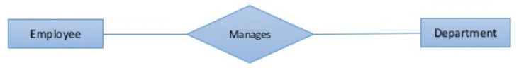In ER, a relationship is shown by a diamond.
* An EMPLOYEE manages a DEPARTMENT is a relationship.
* John Smith manages Human Resources is an instance of that relationship.